<!--This file created 2:29 PM 10/29/97 by Claris Home Page version 2.0-->1.3 Project
A Leaning Ladder

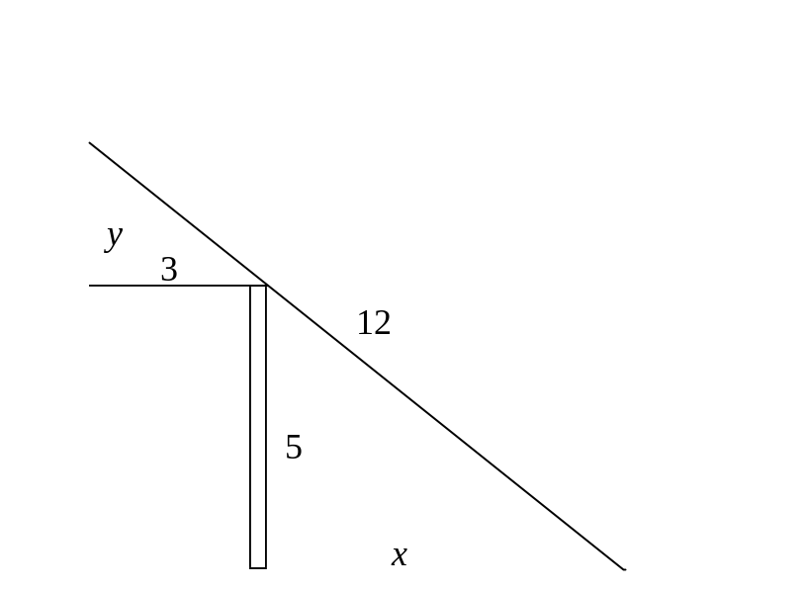

The figure shows a 12-ft ladder that leans across a 5-ft fence and just touches a high wall located 3 feet behind the fence. You are to find the distance x from the foot of this ladder to the bottom of the fence.

Note that x is the base of a right triangle with height 5. The smaller right triangle at the upper left in the figure has base 3 and unknown height y. We can get started by setting up some equations involving the two unknowns x and y. First, the equality of base/height ratios for these two similar right triangles yields the equation

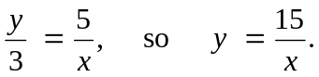 (1)

Then the Pythagorean relation for the largest of the three right triangles in the figure yields the equation
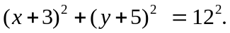 (2)

If we substitute y = 15/x from (1) into (2) and simplify, we get in turn the equations

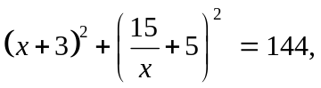

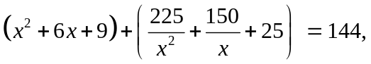

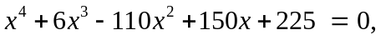 (3)

the final quartic (4th degree) equation resulting when we multiply by x² (to clear fractions) and then collect coefficients of like terms. Our derivation of (3) shows that, if the (positive) number x denotes the physical dimension labeled in the ladder figure above, then x must satisfy this quartic equation.

The graph  for –15 < x < 10 in the figure below indicates that this equation has four real solutions — two of them negative and two of them positive. But only the two positive solutions — one of them apparently near x = 3 and the other near
x = 7 — represent actual physical possibilities for the placement of the foot of the ladder. (Why?)

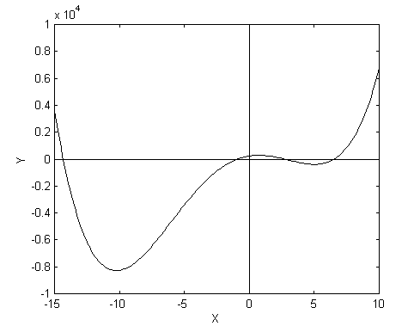

Use the graphical method of successive magnifications to zoom in on each of the four real solutions (accurate to two rounded decimal places) of Eq. (3). Then determine whether both of the two positive solutions correspond to a physically possible position of the leaning ladder as shown in the figure? Is there more than one answer? (Suggestion: For each value of x, verify that it and y = 15/x satisfy equation (2). What does this prove?)

For your own personal ladder problem, let p and q denote the last two nonzero digits in your student ID number (with p the larger), and begin instead with a ladder of length L = 3p feet. Suppose the fence is p ft tall and stands q ft from the high wall.

The sections below illustrate the use of graphing calculators and computer algebra systems to apply the method of magnification and other available numerical methods for the solution of equations.

Using a Graphing Calculator
To investigate the placement of the given 12-foot ladder we need to solve the quartic equation
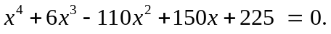

Of course you must derive your own leaning ladder equation (as described on the initial page for this project) in order to investigate a different ladder-fence-wall situation.

In order to use a TI-83 calculator (for instance) to solve our equation, we first define the function f(x). The following calculator screen shows this function defined in the Y= menu.

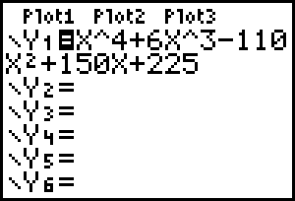

When we plot the graph y = f(x) after entering Xmin = -15, Xmax = 10, Ymin = -10000, Ymax = 5000 in the WINDOW screen, we see the following graph:

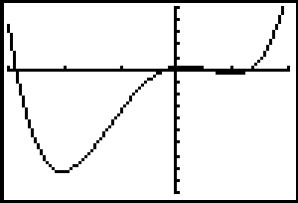

Here it's a bit hard to make out the x-intercepts, so we magnify in the y-direction only by going back to the WINDOW screen and entering Ymin = -1000, Ymax = 1000. This gives the picture

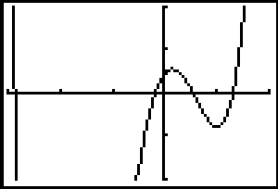

where the x-intercepts are more clearly visible. We see that our equation has four real solutions — two of them negative and two of them positive. But only the two positive solutions — one of them apparently near x = 3 and the other near x = 7 — represent actual physical possibilities for the placement of the foot of the ladder. We can focus on either of these by the method of repeated magnification of the graph. Zooming in on the solution between x = 0 and x = 5, for instance, we get first with Xmin = 0, Xmax = 5, Ymin = -100, Ymax = 100 the figure

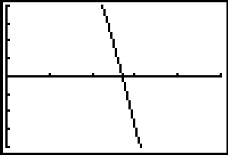

where we see a solution between x = 2 and x = 3. After several more zooms we finally get with Xmin = 2.697, Xmax = 2.698, Ymin = -0.1, Ymax = 0.1 the figure

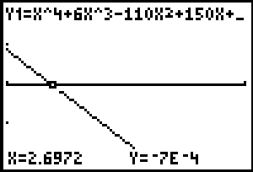

when we Trace the graph. Thus the smaller of the two positive solutions of our quartic equation is x = 2.6972 accurate to 4 decimal places.

Exercise: Find in similar fashion the other 3 solutions accurate to 4 decimal places.
Zooming is time-consuming if you want more than a couple of decimal places of accuracy, so we can use the TI-calculator's built-in graphical root-finder. Suppose we graph our function once again, now with the window with Xmin = 0, Xmax = 10, Ymin = -500, Ymax = 500 in order to see the two positive roots. The figure

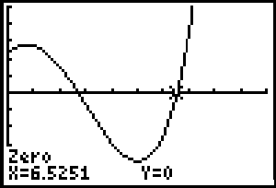

then results if we press 2nd CALC zero and locate the right-hand x-intercept (for instance) with the cursor. So x = 6.5251 is the second positive solution.

It doesn't get much easier than this! But if you really want to make the calculator do ALL the work, you can use the solve function that is entered from the CATALOG menu.

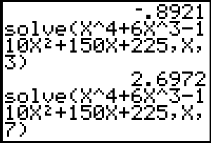

Exercise: Set up your own leaning ladder equation and find all four of its solutions by at least two of these calculator methods.
Using Maple

To investigate the placement of the given 12-foot ladder we need to solve the equation

Of course you must derive your own equation (as described on the initial page for this
project) in order to investigate a different ladder-fence-wall situation.
In order to graph the function on the left-hand side in our quartic equation, we need only execute the plot command
plot(x^4 + 6*x^3 - 110*x^2 + 150*x + 225, x=-15..10);
specifying the interval from x = –15 to x = 10.

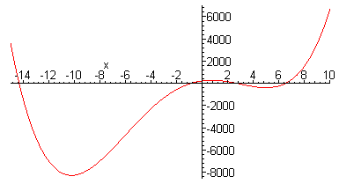

Looking at the x-intercepts of the graph, we see that this equation has four real solutions — two of them negative and two of them positive. But only the two positive solutions — one of them apparently near x = 3 and the other near x = 7 — represent actual physical possibilities for the placement of the foot of the ladder. We can focus on either of these by the method of repeated magnification of the graph. Zooming in on the solution between x = 0 and x = 5, for instance, we execute the successive commands
plot(x^4 + 6*x^3 - 110*x^2 + 150*x + 225, x=0..5);
plot(x^4 + 6*x^3 - 110*x^2 + 150*x + 225, x=2..3);
plot(x^4 + 6*x^3 - 110*x^2 + 150*x + 225, x=2.6..2.7);
plot(x^4 + 6*x^3 - 110*x^2 + 150*x + 225, x=2.69..2.70);
plot(x^4 + 6*x^3 - 110*x^2 + 150*x + 225, x=2.697..2.698);

and see finally the following figure which shows that x = 2.6972 accurate to 4 decimal
places.
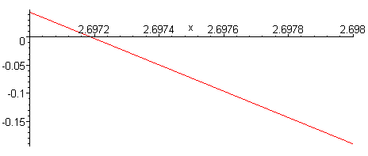

Exercise: Find in this way the other three solutions of our quartic equation.
Of course, if you want to take the easy route, Maple can do the whole job at once:
fsolve(x^4 + 6*x^3 - 110*x^2 + 150*x + 225 = 0, x);

-14.3301, -.892144, 2.69719, 6.52508

Thus we see our 4 roots again. The two positive solutions indicate that we can place the foot of the ladder either about 2 ft 8.4 in or about 6 ft 6.3 in from the base of the fence. [The f in fsolve is for floating-point (that is, numerical, solution). With solve you'd get impossibly complicated symbolic solutions.]
Apply each of these methods to investigate your own ladder/fence/wall situation. The Acrobat Text Tool can be used to select the Maple commands displayed above and copy/paste them into a Maple worksheet for execution one at a time.

Using Mathematica

To investigate the placement of the given 12-foot ladder we need to solve the equation

Of course you must derive your own equation (as described on the initial page for this project) in order to investigate a different ladder-fence-wall situation.
In order to graph the function on the left-hand side in our quartic equation, we need only execute the plot command
Plot[x^4 + 6 x^3 - 110 x^2 + 150 x + 225, {x, -15, 10}]
specifying the interval from x = –15 to x = 10.

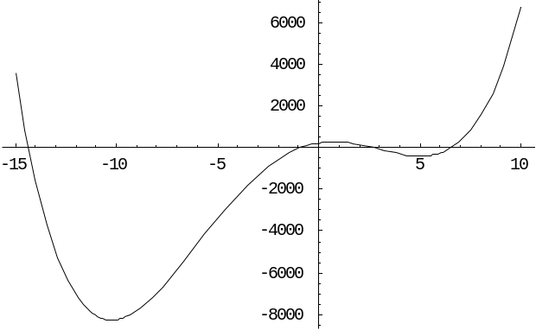

Looking at the x-intercepts of the graph, we see that this equation has four real solutions two of them negative and two of them positive. But only the two positive solutions -- one of them apparently near x = 3 and the other near x = 7 -- represent actual physical possibilities for the placement of the foot of the ladder. We can focus on either of these by the method of repeated magnification of the graph. Zooming in on the
solution between x = 0 and x = 5, for instance, we execute the successive commands
Plot[x^4 + 6x^3 - 110x^2 + 150x + 225, {x, 0, 5}];
Plot[x^4 + 6x^3 - 110x^2 + 150x + 225, {x, 2, 3}];
Plot[x^4 + 6x^3 - 110x^2 + 150x + 225, {x, 2.6, 2.7}];
Plot[x^4 + 6x^3 - 110x^2 + 150x + 225, {x, 2.69, 2.70}];
Plot[x^4 + 6x^3 - 110x^2 + 150x + 225, {x, 2.697, 2.698}];

and see finally the following figure which shows that x = 2.6972 accurate to 4 decimal
places.
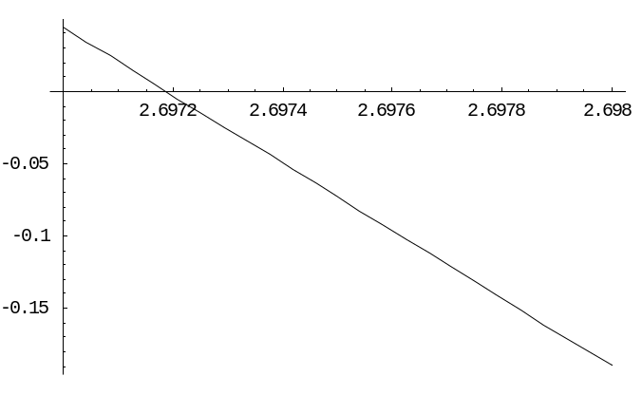

Exercise: Find in this way the other three solutions of our quartic equation.
Of course, if you want to take the easy route, Mathematica can do the whole job at once:
NSolve[x^4 + 6x^3 - 110x^2 + 150x + 225 == 0, x]
{{x -> -14.3301}, {x -> -0.89214}, {x -> 2.69719},
{x -> 6.52508}}

Thus we see our 4 roots again. The two positive solutions indicate that we can place the foot of the ladder either about 2 ft 8.4 in or about 6 ft 6.3 in from the base of the fence. [The N in NSolve is for numerical solution. With Solve you'd get impossibly complicated symbolic solutions.]
Apply each of these methods to investigate your own ladder/fence/wall situation. The Acrobat Text Tool can be used to select the Mathematica commands displayed above and copy/paste them into a Mathematica notebook for execution one at a time.

Using MATLAB

To investigate the placement of the given 12-foot ladder we need to solve the equation

Of course you must derive your own equation (as described on the initial page for this project) in order to investigate a different ladder-fence-wall situation.

In order to graph the function on the left-hand side in our quartic equation, we need only execute the plot command
fplot('x.^4+6*x.^3-110*x.^2+150*x+225',...
[-15 10 -10000 10000]), grid on

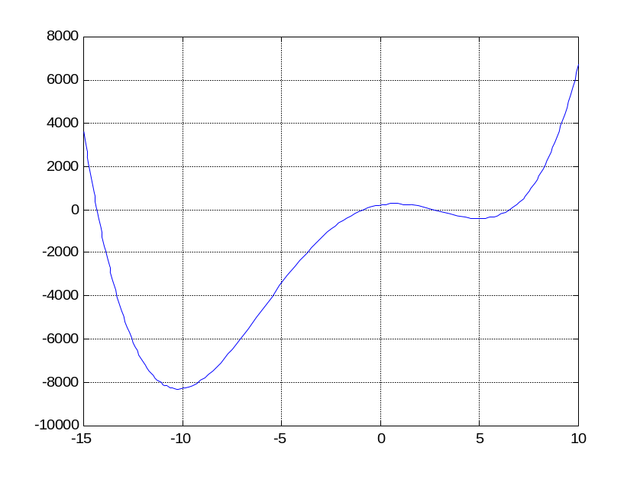

Looking at the x-intercepts of the graph, we see that this equation has four real solutions — two of them negative and two of them positive. But only the two positive solutions — one of them apparently near x = 3 and the other near x = 7 — represent actual physical possibilities for the placement of the foot of the ladder. We can focus on either of these by the method of repeated magnification of the graph. Zooming in on the solution between x = 0 and x = 5, for instance, we execute the successive commands

fplot('x.^4+6*x.^3-110*x.^2+150*x+225',[0 5]), grid on

fplot('x.^4+6*x.^3-110*x.^2+150*x+225',[2 3]), grid on

fplot('x.^4+6*x.^3-110*x.^2+150*x+225',[2.6 2.7]), grid on

fplot('x.^4+6*x.^3-110*x.^2+150*x+225',[2.69 2.70]), grid on

fplot('x.^4+6*x.^3-110*x.^2+150*x+225',[2.697 2.698])

grid on

and see finally the following figure shown at the top of the next page; it shows that
x = 2.6972 accurate to 4 decimal places.

Exercise: Find the other 3 roots in this manner.
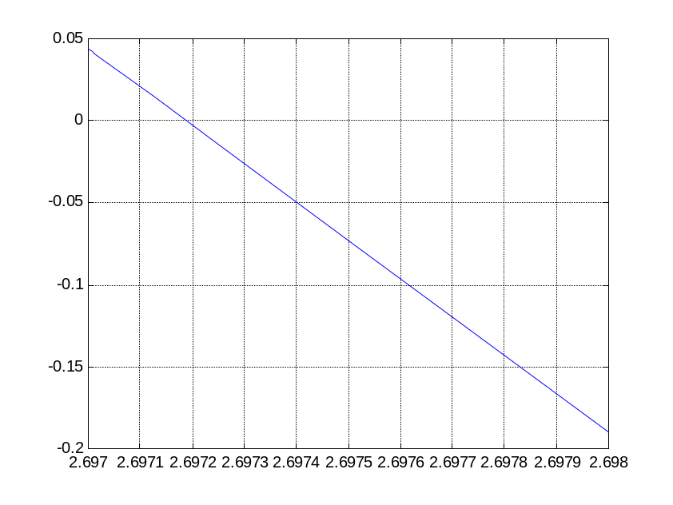
We can use MATLAB's fzero function to approximate all 4 solutions
numerically, glancing at our graph to provide an initial guess for each.
fzero('x.^4+6*x.^3-110*x.^2+150*x+225',-15)
ans = -14.3301
fzero('x.^4+6*x.^3-110*x.^2+150*x+225',-1)
ans = -0.8921
fzero('x.^4+6*x.^3-110*x.^2+150*x+225',3)
ans = 2.6972
fzero('x.^4+6*x.^3-110*x.^2+150*x+225',7)
ans = 6.5251

MATLAB also includes a special polynomial-solver roots that finds
simultaneously all the roots of a polynomial whose "coefficient vector" is input. The coefficients of our polynomial x⁴ + 6x³ - 110x² + 150x + 225 are given (in descending order) by the coefficient vector [1 6 -110 150 225], so the appropriate command is
roots([1 6 -110 150 225])
ans =
-14.3301
6.5251
2.6972
-0.8921
Thus we see our 4 roots again. The two positive solutions indicate that we can place the foot of the ladder either about 2 ft 8.4 in or about 6 ft 6.3 in from the base of the fence.
Apply each of these methods to investigate your own ladder/fence/wall situation.
The Acrobat Text Tool can be used to select the MATLAB commands displayed above and copy/paste them into a MATLAB command window for execution one at a time.

